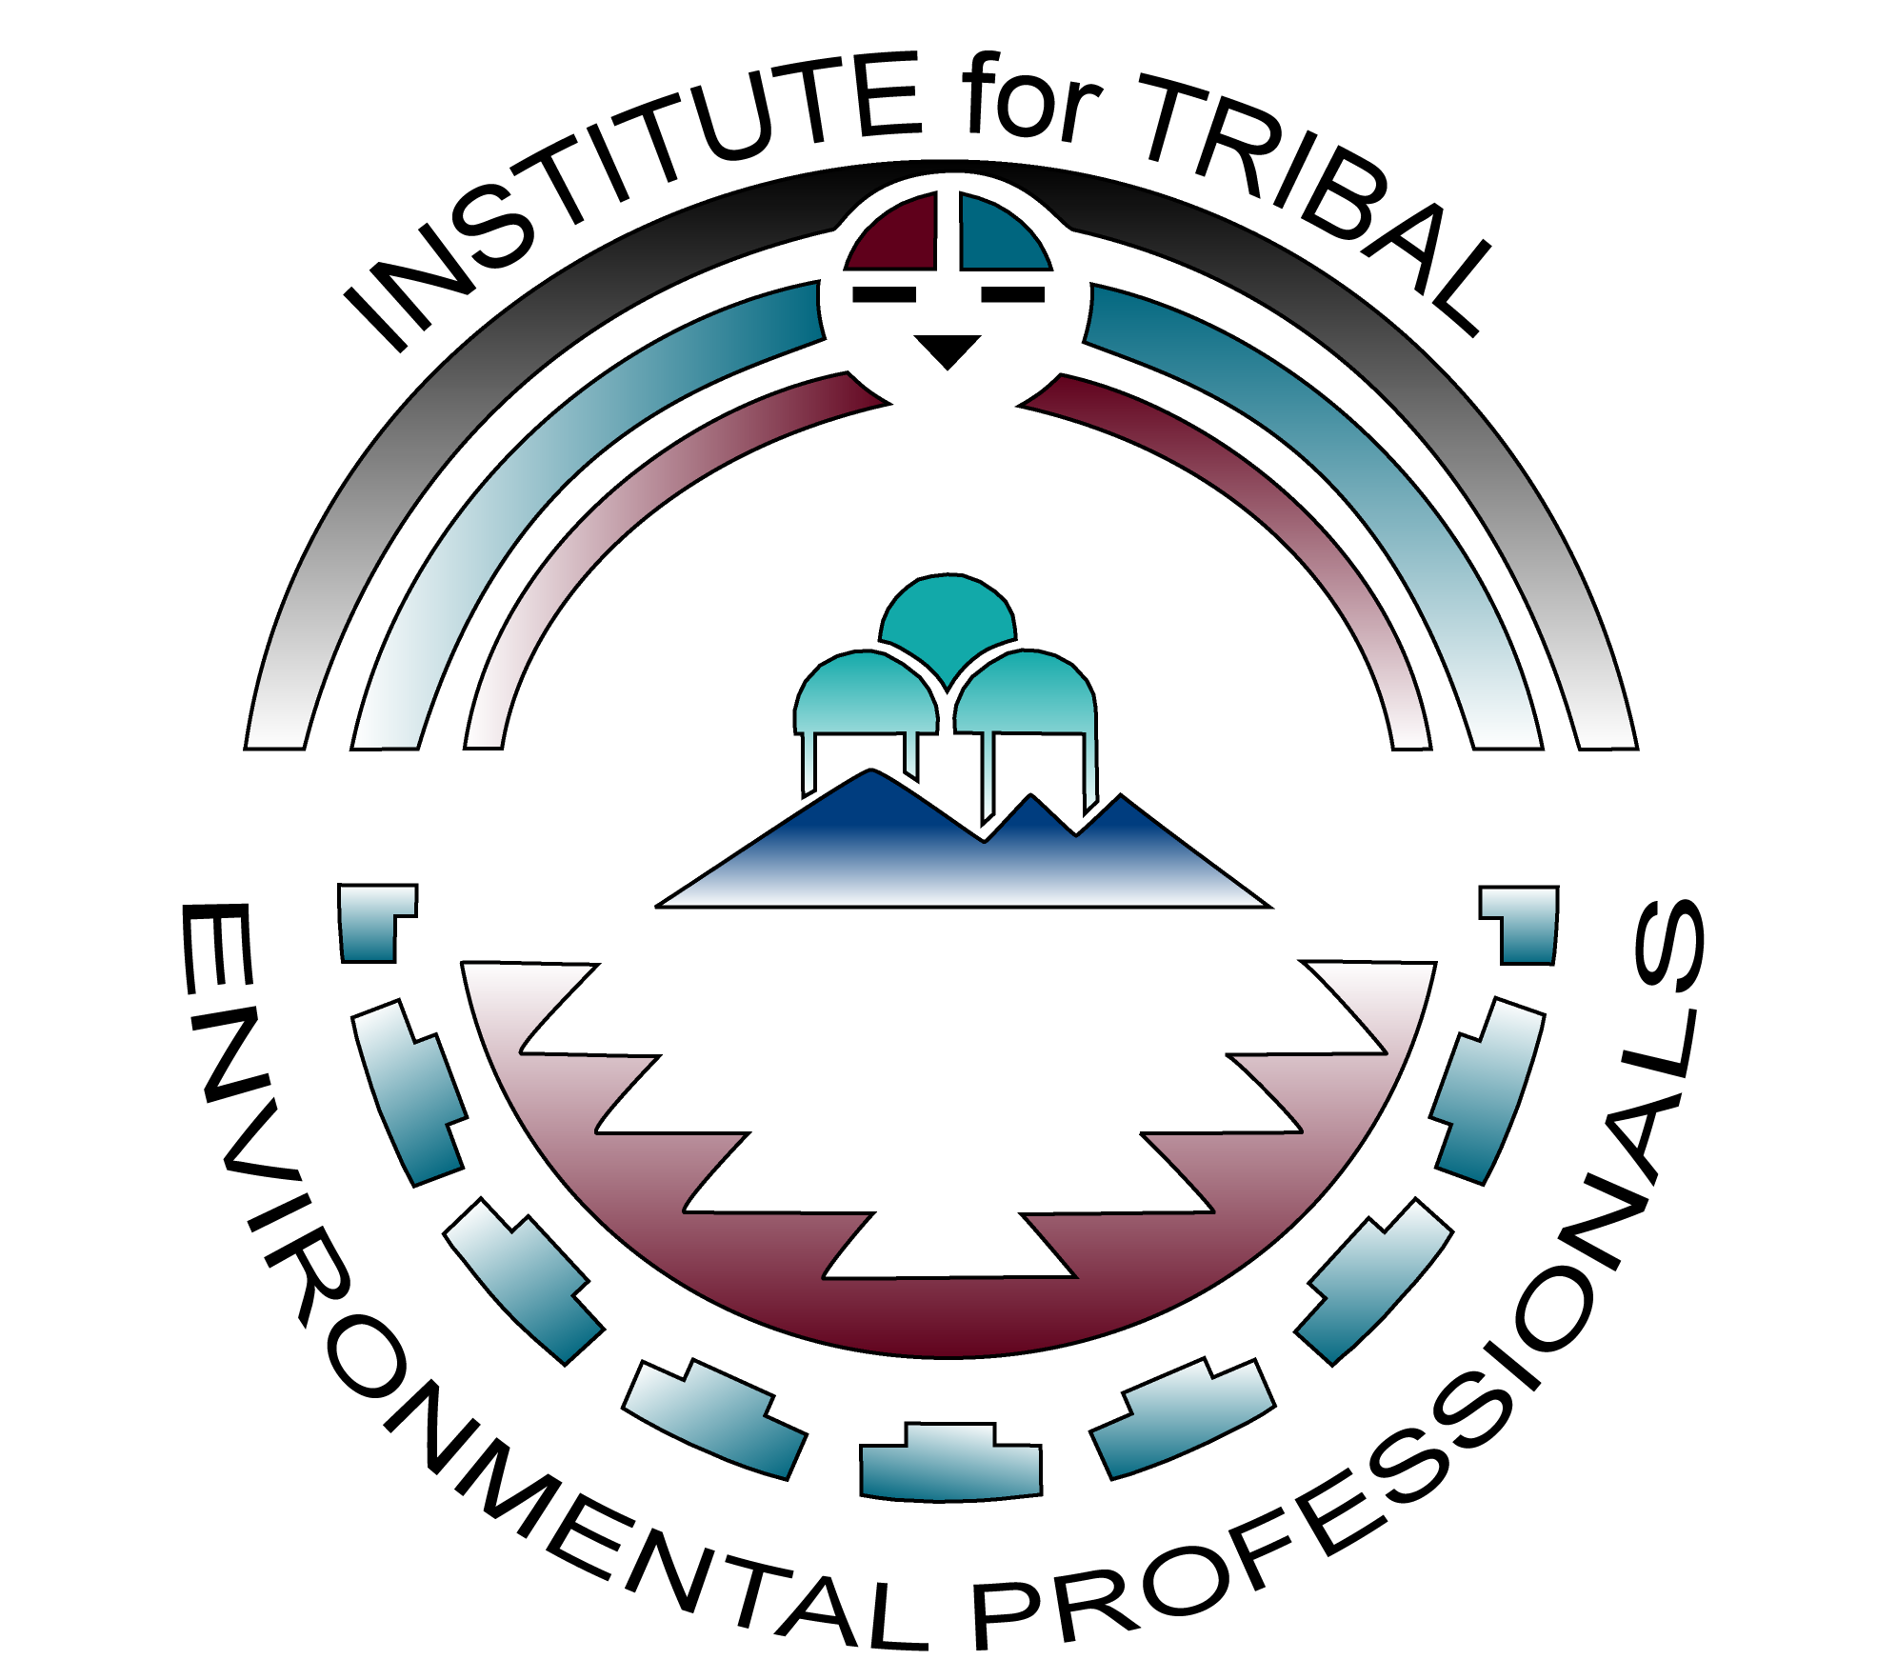

Institute for Tribal Environmental Professionals

Development and Implementation of Tribal Solid Waste Codes and Ordinances
Virtual Training: February 1-4, March 3, and April 20-23, 2021

The Institute for Tribal Environmental Professionals, the Indian Health Service (IHS), and the United States Environmental Protection Agency are pleased to offer the fourth year of “Development and Implementation of Tribal Solid Waste Codes and Ordinance” training course to employees of federally-recognized tribes. An applicant to this course should work for a tribe that has a completed integrated solid waste management plans but lack operable solid waste codes/ordinances. This virtual course with online assignments and follow-up workshop will focus on the writing and implementation of effective tribal solid waste codes. It has been developed for tribal environmental professionals without law experience, yet all level of experience, other tribal staff, and council members are welcome. Each tribe that completes the training will receive legal and technical staff support via phone, email and/or web based meeting communication and shall include one-on-one assistance in developing their codes and ordinances. Complete attendance is required to receive legal and technical staff support and a certificate.
COURSE HIGHLIGHTS
Importance of Developing Community-Specific Codes & Navigating the Jurisdictional Labyrinth
Drafting Codes – Conducting Research and Deciphering Code Language & Identifying Solid Waste Issues
Outreach Methods & Strategies for Cultivating Public, Legal, and Governmental Support
Enforcement Issues, Enforcement Options, Enforcement Alternatives
Conducting/Managing Legal Review/Administrative Processes

ELIGIBILITY
This tuition-free course is specifically designed for tribes who intend to create solid waste codes and are in a position to enforce the completed codes. Course participants must be employees of federally-recognized tribes that currently have completed integrated solid waste management plans but lack operable solid waste codes/ordinances.

APPLICATION PROCESS
Participants applying for the “Development and Implementation of Tribal Solid Waste Codes and Ordinance” virtual training course are required to:
- Create a student profile through the IHS Environmental Health Support Center web portal at www.ihs.gov/ehsc/ by selecting Registration Instructions on the left-side toolbar; after logging in, apply by selecting Classes left-side toolbar, typing “codes” into the search bar, select course, and scroll to the bottom to “Register” (call Shari Windt at 505-256-6805 for assistance creating your profile), AND
- Complete ITEP’s online application available at https://bit.ly/SWCodes2021.

The course will be limited to twenty-five participants and is competitive. Creating an IHS profile and completing an ITEP application does not guarantee acceptance. A notice of confirmation and fact sheet with additional course details will be sent to those who are selected to participate in the course.

Attendees accepted to the “Development and Implementation of Tribal Solid Waste Codes and Ordinance” virtual training course are required to:
- Complete a pre-course assignment, pre-test, and self-assessment (requires approximately 2-4 hours) prior to January 27, 2021. Successful applicants will be notified of their acceptance into the course on January 11, 2021.
- Attend 40 hours of virtual training (schedule below) via Zoom with cameras turned on. Please notify ITEP in advance if this is an issue so arrangement can be made.
- Complete online course work, requiring an additional 20-30 hour commitment from Februray 5 - March 31, 2021, including completing assignments, discussions forums with other course participants, and developing a draft solid waste code no later than March 31.
- Commit to the development/revision and implementation of a solid waste management code or ordinance within 12 to 18 months of completing this training course.

VIRTUAL TRAINING DATES & TIMES
The 40 hours of virtual training via Zoom (with cameras turned on) is scheduled for the following dates and times:
- February 1, 2, 3, and 4, 2021 at 9:00am-2:00pm PST; 10:00am-3:00pm MST; 11:00am-4:00pm CST; 12:00pm-5:00pm EST
- March 3, 2021 at 9:00am-1:00pm PST; 10:00am-2:00pm MST; 11:00am-3:00pm CST; 12:00pm-4:00pm EST
- April 20, 21, 22, 23, 2021 at 9:00am-2:00pm PDT; 10:00am-3:00pm MDT; 11:00am-4:00pm CDT; 12:00pm-5:00pm EDT

CANCELLATIONS
Please notify ITEP as soon as possible if you need to cancel. No shows impact opportunities for other tribes to attend and will jeaopardize your eligibility for future trainings.

