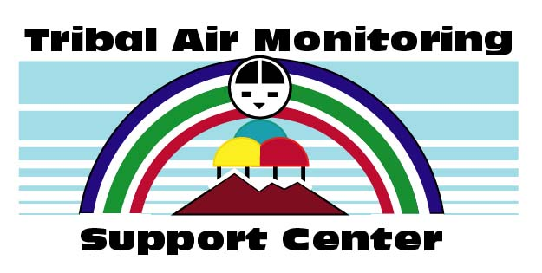
Tribal Air Monitoring Support:
TAMS Center
-A Model Partnership for a Healthier Environment-

Steering Committee Nomination Form

The Tribal Air Monitoring Support (TAMS) Center is currently accepting nominations for two (2) positions on the TAMS Steering Committee. TAMS Steering Committee members serve three-year staggered terms. These positions will serve terms that run from October 1, 2022 to September 30, 2025. If you would like to nominate a potential candidate, please submit the attached nomination form. Self-nominations are also accepted. Nominee resumes are not required but are highly encouraged.

- Any person engaged in tribal environmental quality issues may make nominations.
- Nominees must be affiliated with a federally recognized tribe or intertribal group and must be engaged in tribal environmental quality issues.
- Voting members of the Steering Committee shall elect individuals from the pool of nominees to fill open seats on the Steering Committee. The intent of the Steering Committee is to provide broad, regional representation. Such representation is one consideration for member selection.

Deadline for nominations: February 25, 2022

An authorization letter or correspondence from an appropriate elected official(s) or the nominee’s supervisor will be required for Steering Committee membership.

To view the current Steering Committee member list and term information, please visit the TAMS website: http://www4.nau.edu/tams/scommittee/members.asp. Feel free to contact them for information on roles and responsibilities.

Return your nomination forms to:
Darlene Santos, Administrative Associate
U.S. EPA-TAMS Center
4220 S. Maryland Parkway, Bldg C
Las Vegas, NV 89119
(702) 784 - 8264
Fax: (702) 784-8201
Email: darlene.santos@nau.edu

Thank you for your interest. If you have any additional questions, please do not hesitate to call.

Christopher Lee Hayden Hardie
ITEP Co-Director, TAMS Center EPA Co-Director, TAMS Center
(702) 784-8278 (702) 784-8263
Christopher.Lee@NAU.EDU Hardie.Hayden@EPA.GOV
Tribal Air Monitoring Support Center
Use extra paper if necessary
Steering Committee Member Nomination Form
Please feel free to use an extra sheet of paper if more space is needed.

Nominee information:

Name: |  |  | Phone: | Click here to enter text.
Mailing address: |  | Click here to enter text.
Email address: |  | Click here to enter text.
Tribe (employer): |  | Click here to enter text.
Job Title/Position: |  | Click here to enter text.

Examples of tribal environmental service in which Nominee has demonstrated leadership:
Click here to enter text.

Examples of tribal environmental service in which Nominee has demonstrated commitment:
Click here to enter text.

Examples of tribal environmental service in which Nominee has demonstrated community involvement:
Click here to enter text.

Examples of the success and impact of Nominee’s environmental service:

● ● ● ● ● ● ● ● ● ● ● ● ● ● ● ● ● ● ● ● ● ● ● ● ● ● ● ● ● ● ● ● ● ● ● ● ● ● ● ● ● ● ● ● ● ● ● ● ● ● ● ●

Your information (nominator):

Name: |  |  | Phone: | Click here to enter text.
Mailing address: |  | Click here to enter text.
Email address: |  | Click here to enter text.
Tribe (employer): |  | Click here to enter text.
Job Title/Position: |  | Click here to enter text.

