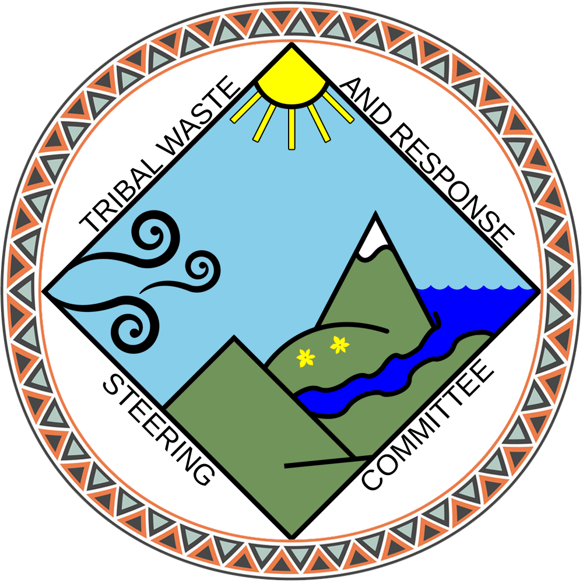
Tribal Waste and Response
Steering Committee

The Institute for Tribal Environmental Professionals (ITEP) is seeking applications for our national Tribal Waste and Response Steering Committee (TWAR SC). Accepted new members will join TWAR SC for the term beginning on March 1, 20XX and ending February 28, two years later. Applications must be submitted by October XX, 20XX, and applicants will be notified following the selection process (December/January). When submitting your application, please include your resume and up to three letters of recommendation.

Since 2008, ITEP has worked in cooperation with the US Environmental Protection Agency's (USEPA) Office of Land and Emergency Management (OLEM) coordinating the TWAR SC, developing Tribal waste management and response training, providing technical assistance, and conducting the annual Tribal Lands and Environment Forum (TLEF). This program covers solid waste, brownfields, Superfund, Underground Storage Tanks (USTs), and emergency response programs. The TWAR SC is composed of Tribal experts in these fields who assist ITEP and OLEM in the successful development and implementation of these media, and insuring two-way communication between Tribes, ITEP, and OLEM. The TWAR SC also produces the Priority Document on OLEM-related media, which is provided to both senior USEPA management and the National Tribal Caucus. This Priority Document identifies and communicates Tribal needs and priorities to senior USEPA personnel, and assists them in shaping their own priorities and budgets.

Each year, the Steering Committee meets six times a year; two of the meetings take place in person, one being held in Washington DC, so committee members may meet with their federal colleagues and discuss issues of Tribal relevance, and the second meeting held at the location being used for that year’s TLEF. In addition to these two in person meetings, there are at least four meetings held online per year. Steering Committee members also attend the TLEF each August. ITEP reimburses Steering Committee members for their travel, lodging, and per diem expenses, so their tribes do not incur any costs for their travel to these in-person meetings and the TLEF.

TWAR SC members are appointed to two-year terms. At the conclusion of their terms, members may apply to serve an additional term. The Steering Committee established a Charter which governs their activities, and this Charter is reviewed on a regular basis, and amended if needed, by the Steering Committee members.

Criteria for the Selection of Steering Committee Members

- Steering Committee members must be employed by a federally recognized tribe, Alaska Native Village of Tribe, or an Alaska Native consortia, and currently work in the field of solid waste, hazardous waste, brownfields, Superfund, federal facilities, USTs or emergency response.
- Steering Committee members must be able to participate in a minimum of six meetings per year, as well as attend the annual TLEF.
- Steering Committee members must be willing to serve, at a minimum, one two-year term with supervisor approval. (NOTE: ITEP will confirm supervisor approval prior to selecting Steering Committee members)
- Steering Committee members must be able to inform ITEP of Tribal environmental priorities and goals, be willing to provide suggestions to OLEM through the Priority Document and other mechanisms, and assist ITEP with various projects, including the annual TLEF.
- Steering Committee members must be able and willing to work with ITEP in disseminating relevant information about project activities at regional Tribal trainings and conferences.

To view meeting notes, the Steering Committee Charter, and their Priority Documents, please visit http://www7.nau.edu/itep/main/Waste/waste_ntsc.
Tribal Waste and Response
Steering Committee

Application
(All applications are due by October XX, 20XX)

Contact Information

Name

Title

Address

City, State, ZIP

Phone

Email

Please answer the following questions:

1. Are you willing and able to participate in a minimum of six meetings per year (four online and two in person), attend the TLEF in August, and serve a minimum of a one two-year term?

YES NO

2. Will you be able to secure the approval of your supervisor to participate in Steering Committee activities prior to being appointed to the Steering Committee?

YES NO

Please provide your Supervisor's contact information so that ITEP may contact them to verify their approval if you are selected to serve on this Steering Committee:

Name

Title

Address

City, State, ZIP

Phone

Email
3. Have you served on other steering or organizing committees? If so, please discuss the role you played, activities you engaged in, when you served, and how you think this would help you serve on this committee.

4. Please describe your professional experience working with a Tribe or Native Village in the fields of Superfund, emergency response, solid waste, USTs, and/or brownfields programs.

5. Please describe any activities you have participated in which illustrate your involvement in protecting Native American lands and people beyond your own immediate work for your Tribe or Native. (For example, service on regional working groups, professional associations, assisting other Tribal professionals one on one or in training courses, etc.)

6. Please list any relevant training you have taken and/or any presentations you have given at Tribal conferences, forums and/or training courses.

7. Please describe any experience you may have in engaging with the broader community, mentoring others, conducting education activities, and/or participating in research activities.

8. Please tell us why you want to serve on the TWAR SC.

Please return your completed application, along with a copy of your resume and up to three letters of recommendation, to:

Todd Barnell, Program Manager
todd.barnell@nau.edu

