AADR MEETING MINUTES
January 19, 2005

Members Present: Ron Pitt, Cynthia Childrey, Joe Collentine, Ilene Decker, Gypsy Denzine, Art Farmer, Eileen Mahoney, Patrick Deegan, Tom Knights, Tom Kolb, Lin Larson, Barry Lutz, Cindy Mortensen, Joanne Hood, Larry Gould, Karen Pugliesi, Roberta Kelly, Kathy Savage,

Ron Pitt announced that he is working with chairs to determine which courses an International Student “Student Group” can be attached in order for these students to satisfy course requisites. This process is for exchange students only. No CBA courses will be on the list nor will capstone courses. He asked members of AADR to assist with this project since the responses from academic department chairs has been very slow.

Larry Gould reported that no additional information was available on the addition of + and – to the grading basis for graduate and undergraduate courses. He will make a report on this issue at the March meeting.

Joanne Hood announced that Admissions is working on materials that will be used to recruit the fall 2006 class. In order to have the most up-to-date information she is requesting the academic units to let her know if they are going to be using a “pre-major” plan in addition to the major plan. Discussion ensued regarding the elimination of the “pre-major” plans and the use of student groups or milestones as requisites to the program/upper division course work. The question was asked that if we eliminated “pre-major” distinctions, would the use of milestones allow a department to distinguish between students who are actually in the major and those who are completing requisite course work. The answer to this question is- yes.

Ron Pitt raised the issue of charging a higher fee for student who wish to add a 16-week course after the 21-day headcount has been finalized. UA has such a fee. The AADR group expressed support for adding such a fee. Ron Pitt was charged with gathering information about how many late adds were processed after the 21-day head count for Spring and Fall 2004.

Gypsy and Kathy reported that they had presented the issue on Summer WEB courses to the Dean’s council. It is their understanding that the issue has been turned over to the Committee headed by Dean Mason Gerety on Summer School and that no other involvement at the AADR level is warranted. Kathy did mention that there are issues with hybrid courses as well as pure WEB courses. The issues were not enumerated.

Ron Pitt notified the members that he had received a request to change the Final Examination Schedule by rolling forward one day each semester. AADR members did not support this request and favor keeping the schedule static from one semester to the next.

Next meeting is February 2, 8 a.m. in Babbitt 206.
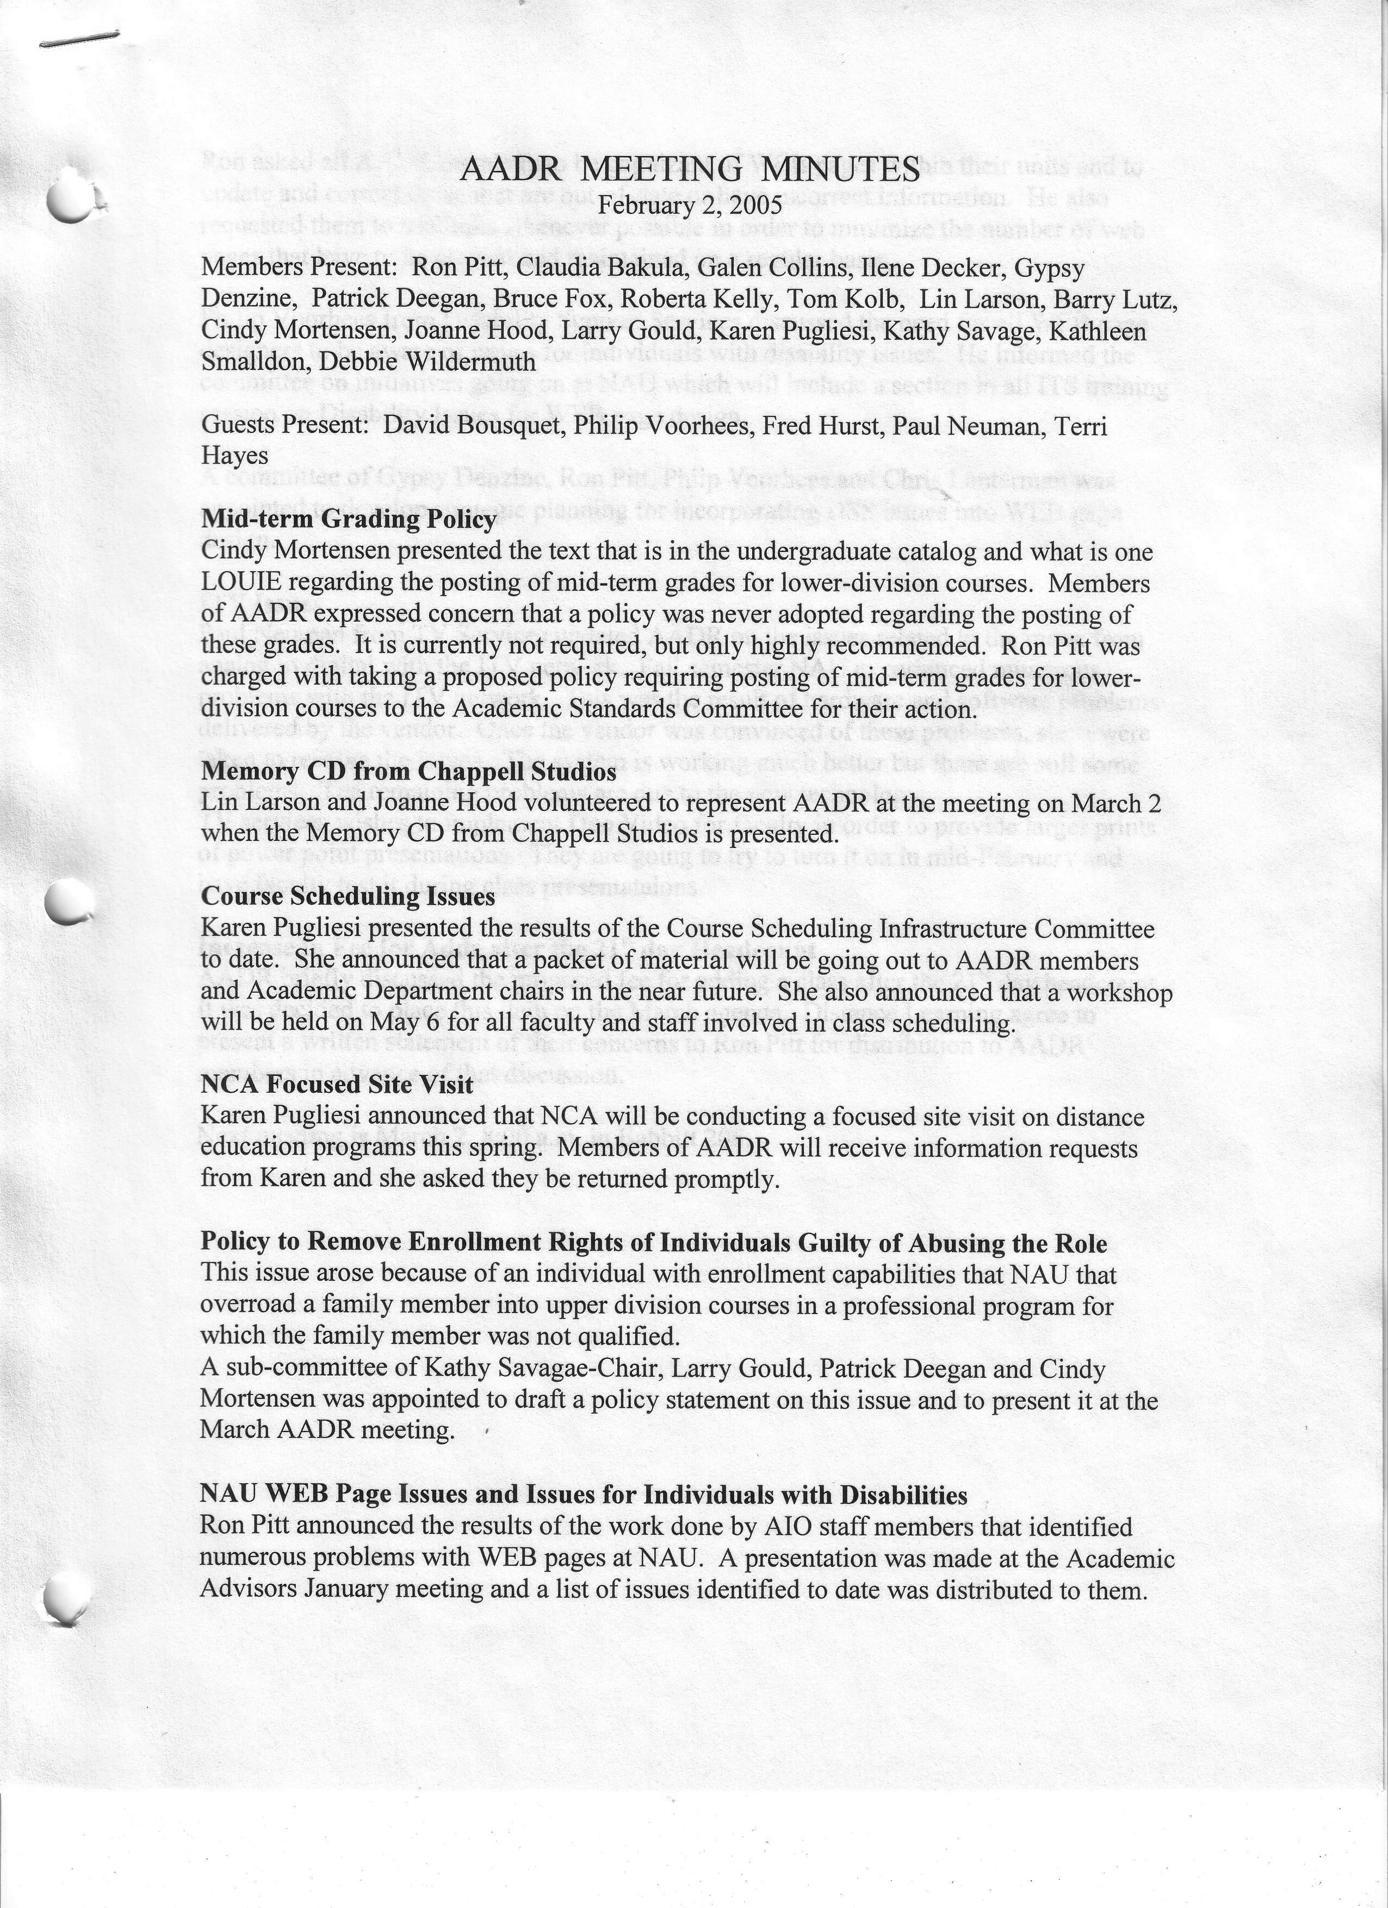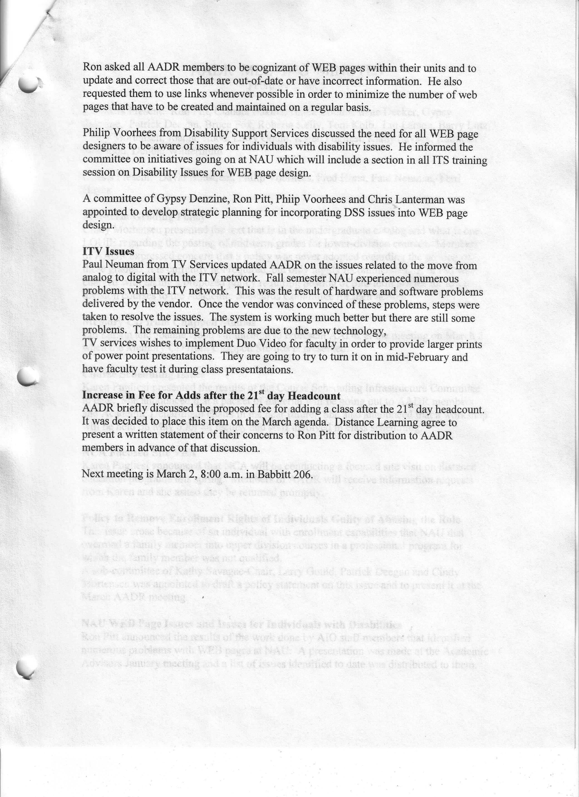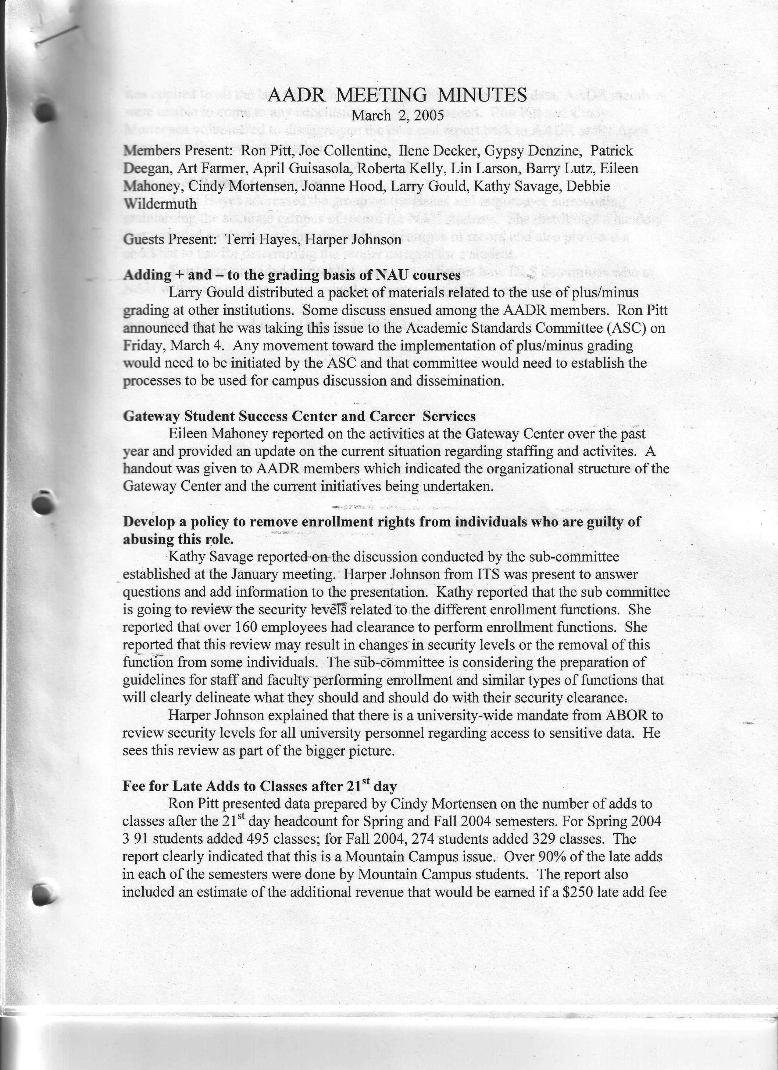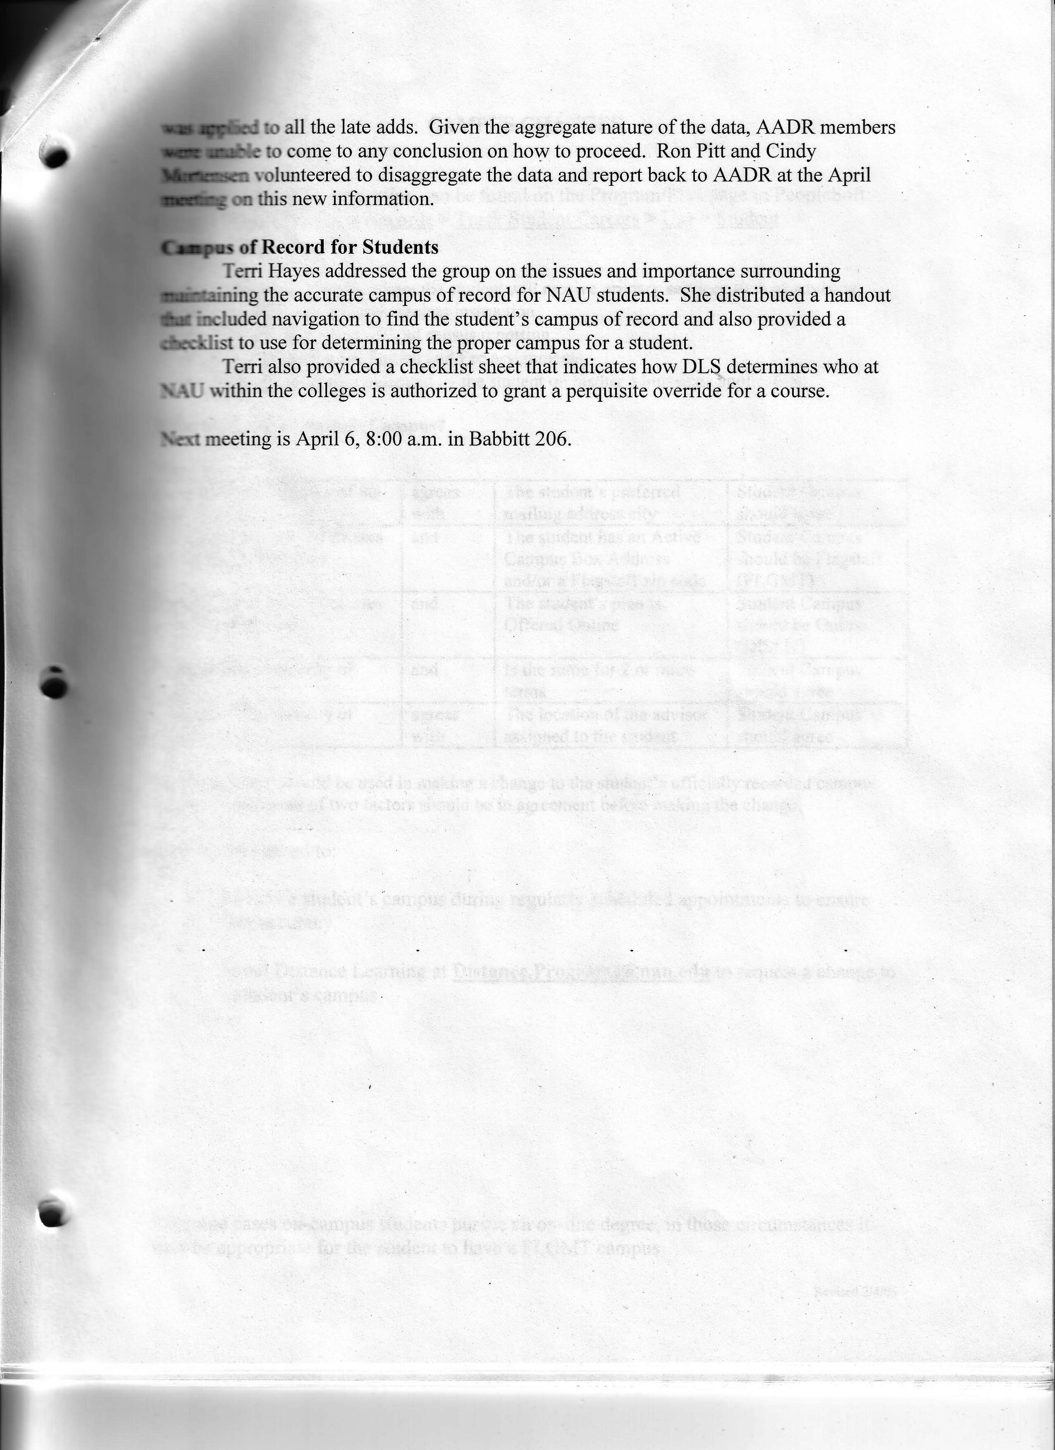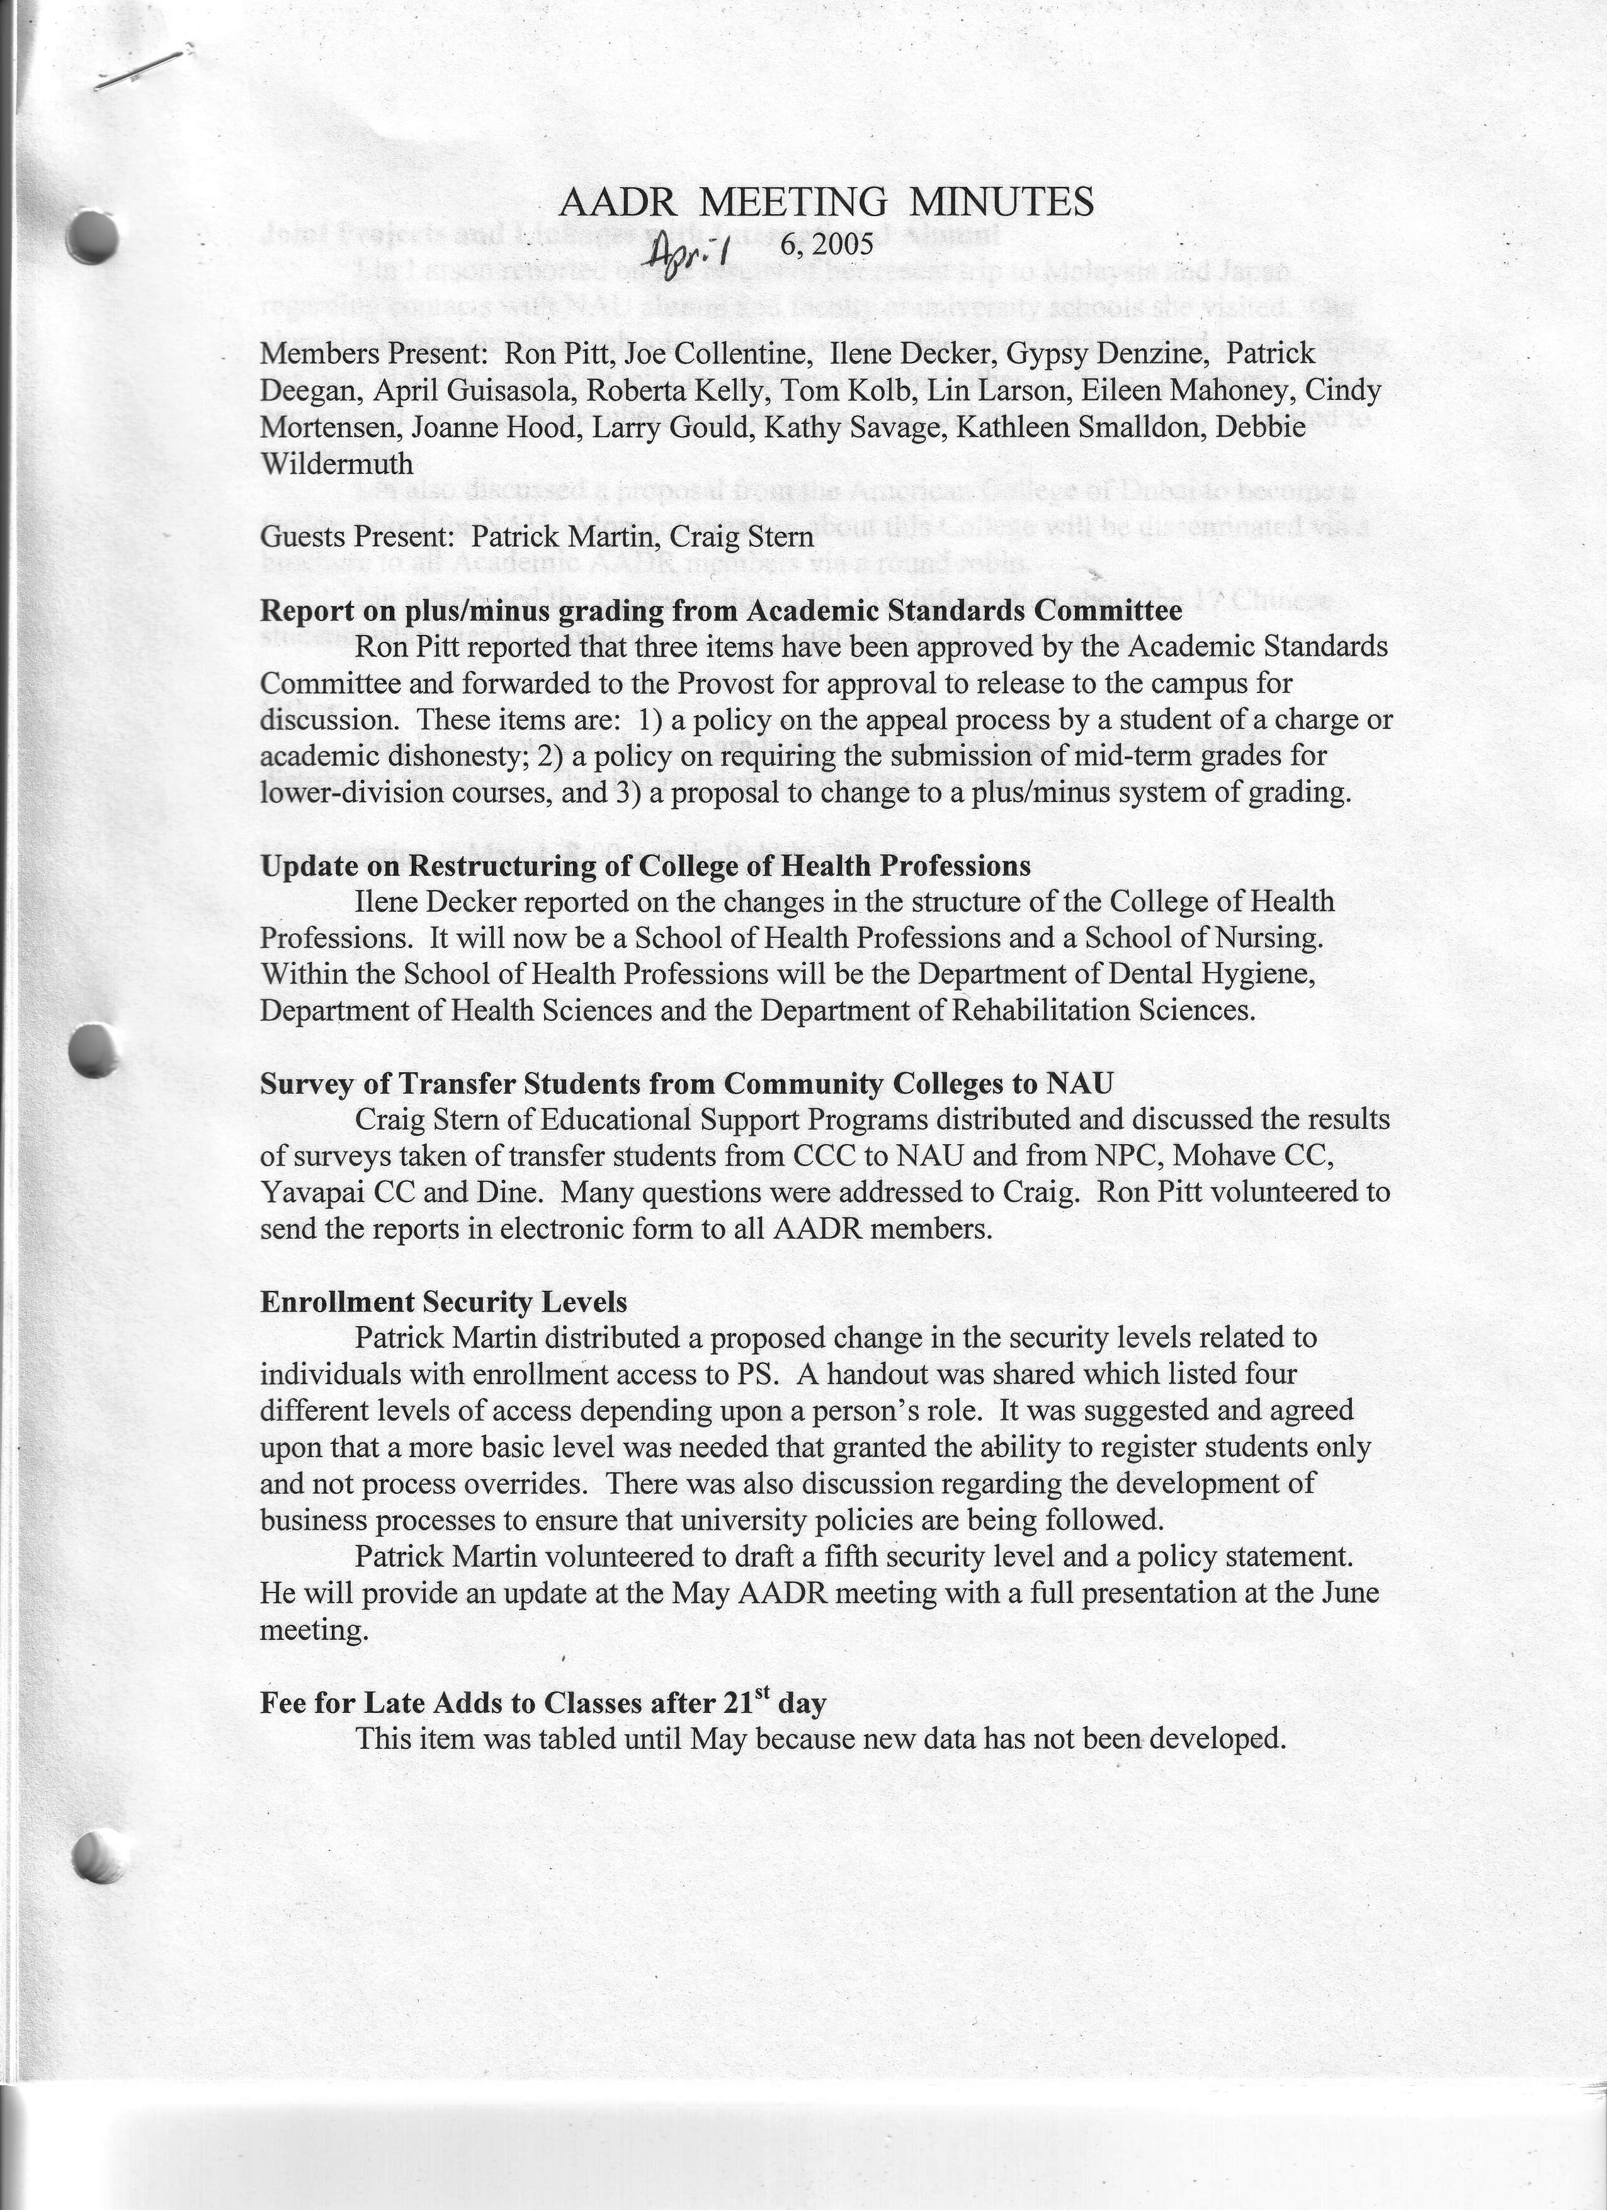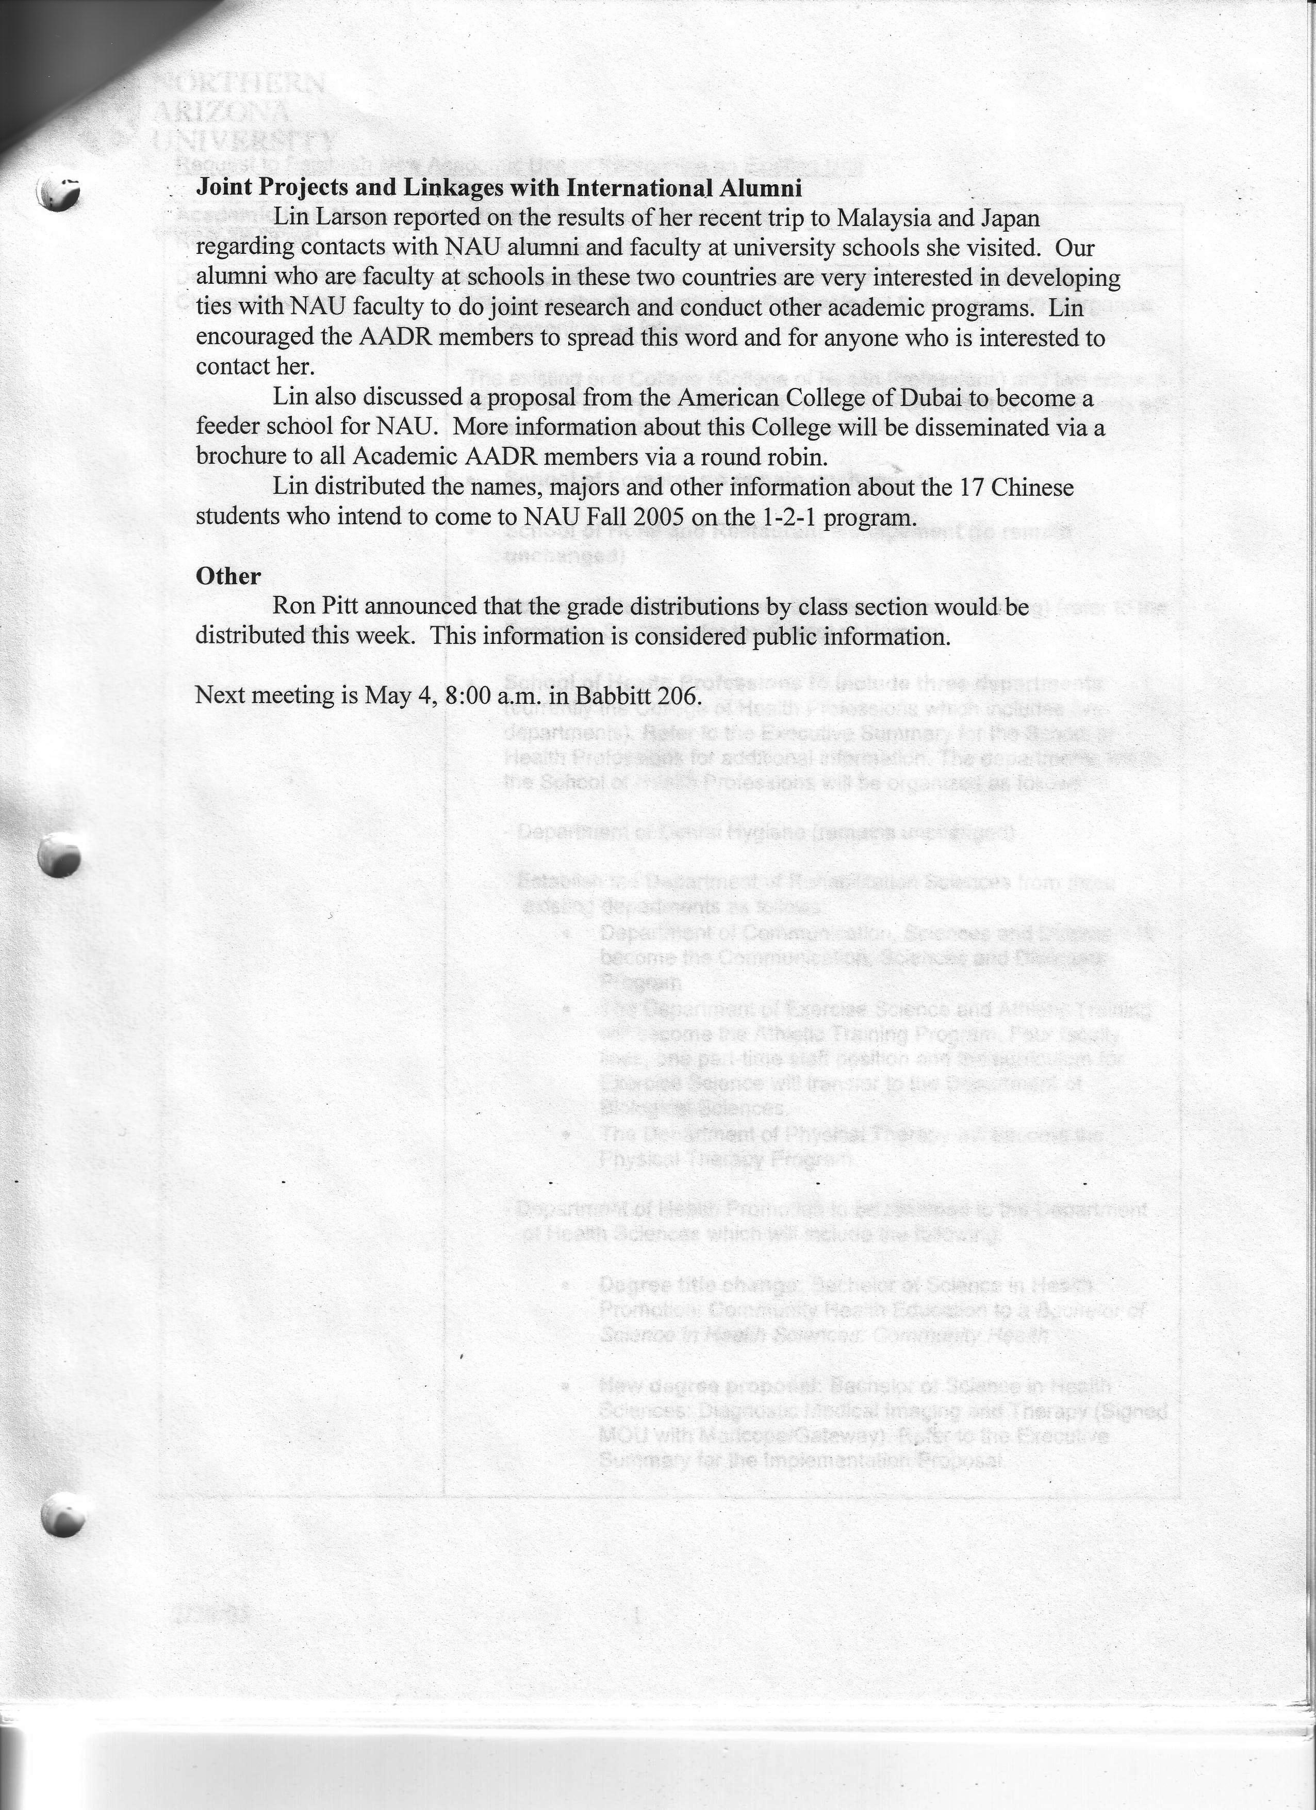

AADR MEETING MINUTES
May 4, 2005

Members Present: Ron Pitt, Joe Collentine, Ilene Decker, Gypsy Denzine, April Guisasola, Art Farmer, Roberta Kelly, Tom Kolb, Lin Larson, Cindy Mortensen, Karen Pugliesi, Kathy Savage, Kathleen Smalldon, Debbie Wildermuth

Guests Present: Patrick Martin, Patty Moore, Priscilla Harden, Terri Hayes, Leah Lommel, Dena Servis

Fee for Late Adds to Classes after 21st day - Cindy Mortensen and Ron Pitt
Ron Pitt had distributed an analysis of adds to classes after the 21st day for the Spring and Fall 2004 semesters. Spring 2004 there were 298 and Fall 2004 there were 211 course adds after the 21st day of the semester with 96% of them being on the mountain campus. For both semesters 53% of the late adds were juniors and senior. Late adds by graduate students were 17% and 12% respectively.
Following discussion about the impact on distance education students, the AADR recommended the fee be increased to $100 and it apply only to 16-week classes. Ron Pitt is to take this recommendation to the Provost for distribution to Dean’s Council and President’s Cabinet.

Change in Grading Deadline - Cindy Mortensen
Cindy Mortensen announced that the grading deadline is moved back 12 hours from noon to midnight which will give faculty that much more time to post grades. A new modification to the system will deny access to the grade rosters after midnight so that faculty will not post grades and believe they are done.

Report on the online course evaluation process - Gypsy Denzine
Gypsy Denzine explained the process for the online course evaluation system that has been adopted by COE. The decision to go to an online evaluation form was an administrative decision in the College.
ITS notifies the unit when the forms are ready. The unit then has to open them up for input and set a closing date. Two weeks prior to the end of the semester – prorated for classes of shorter duration – students and faculty receive an email telling them the evaluations are ready to be completed. At the midpoint of the evaluation period, the faculty member received another email notifying him/her of this date and how many have completed the evaluation to date. The evaluations are available to faculty 3 days after grades are due for the session. Faculty have to go out and get the evaluation.
The College is working on how to structure the reporting – they have not spent a lot of time on this aspect of the process. They spent most of their time on security and infrastructure. John Campbell and Cynthia Conn were instrumental in getting the form developed and on line.
Positive aspects of the system
Costs less than the paper-based system
Get immediate feedback which is useful for decision making
Cleans up the registration issue since only students registered in the class can do the evaluation
Is facilitating the creation of an electronic portfolio which is where COE is going on faculty evaluation
Negative aspects of the system
Faculty blame any decreases in evaluations on the system
The response rate is 40% to 50% - takes three years to get to 70%
Problem keeping folks from wanting to move to yet another electronic system
Faculty asked that responses of less than 50% not be used for the faculty evaluation process

DLS Course Scheduling System for Distance Learning and Summer School - Leah Lommel, Priscilla Harden, Dena Servis, Patty Moore, Terri Hayes
Leah Lommel gave an update on what is available on PS 8.0 and what appears to be available on PS 8.9 and stated it is extremely doubtful that new next PS edition would contain the features needed by DLS.
Priscilla Harden explained the functions that the DLS system performs that PS does not and briefly explained alternative procedures that would have to be implemented if the DLS system was abandoned.
Discussion time was limited so all agreed to come to the June meeting for questions.

China Update - Lin Larson
Gave an update on the China programs, distributed list of students planning attending NAU in Fall 2005, and distributed draft of the Faculty Mentors Guide to be used by faculty mentors to the 16 Chinese faculty arriving in August.

Analysis of Security Roles for PS Enrollment Function – Patrick Martin
Patrick distributed proposal for new security functionality for this process. Full report will be forthcoming in June.

Items from Academic Standards Committee for AADR Review - Ron Pitt
Item tabled until June meeting

Next meeting is June 8 in Sycamore room of University Union.

AADR MEETING MINUTES
June 8, 2005

Members Present: Ron Pitt, Sherry Markel for Gypsy Denzine, April Guisasola, Art Farmer, Bruce Fox, Roberta Kelly, Lin Larson, Eileen Mahoney, Cindy Mortensen, Patty Moore, Kathy Savage, Kathleen Smalldon, Debbie Wildermuth

Guests Present: Priscilla Harden, Dena Servis

AADR Meeting Dates
Meeting dates for summer 2005 and for the 2005-2006 academic year were approved. The Dates are as follows:
Summer 2005
July 13 and August 10

Academic Year 2005-2006:
August 31 September 28 October 26 November 30 December 14
January 25 February 22 March 29
April 26 May 31
All academic year meetings are in Babbitt 206 except for December 14. Honors will host this meeting.

DLS Course Scheduling System for Distance Learning and Summer School
Priscilla Harden and Dena Servis discussed proposed changes in Summer School. They stated a proposal had been made to build the SS classes on the PS system instead of using the DLS system. This will add work to the college staff members in regard to the financial side of the process. In addition, various reports and communications from DLS will not be available which will add work to the DLS staff members because the information will have to be accessed in different ways to prepare these reports. Over 1,100 PARS are generated for summer school and 50% of them are for the Mountain Campus. These are all done by DLS and if the PS system is used for summer school, this will fall to the academic units to do. In addition, there are various profit and loss reports will not be available to the units because these are done on the DLS system.

All at the meeting agreed that the Financial System used for Summer School is overly complex and need to be simplified. It was stated at the AADR meeting that this was also the recommendation of the Summer School Committee.

Ron Pitt was asked to discuss with the Provost the Summer School Committee report and the resultant change in processes. It was suggested that any proposal coming out of the SS Committee be distributed and input solicited from the units, AADR and Chairs Council

Items from Academic Standards Committee for AADR Review
Ron Pitt announced that three proposed policies from Academic Standards Committee had been emailed to all members on June 7. These three policies will be on the July AADR agenda for feedback to Ron.

Report on analysis of security roles related to function in PS
Patrick Martin could not attend the June meeting. This report will be at the July meeting.

Athletic Certification Process
Ron Pitt thanked all individuals who had participated in this process this spring. A small committee is putting together a suggested process for future years. This will be disseminated for feedback after it is prepared.

Library Update
Kathleen Smalldon reported on changes at Cline Library. July 7-12, the library will be recarpeting the first and second floors. Use will be restricted to NAU staff and faculty. The Copy Service will be relocated to the first floor.
The Library is building a portal to let students search multiple data bases at one time. This should be ready in Fall 2005 – by the end of September.
The Library will do a wireless technology project with a projected completed date of fall 2005. This project is using money from the technology fee. They will also purchase 20 laptop computers students can check out and use in the Library.
The library is also installing web based citation management software, which allows students to select formal, bibliography, etc. to assist them with their research. Target completion date is Fall 2005.

Next meeting is July 13 – location to be announced.

AADR MEETING MINUTES
August 10, 2005

Members Present: Ron Pitt, Pat Baron, Joe Collentine, Galen Collins, Ilene Decker, Patrick Deegan, Sherry Markel for Gypsy Denzine, Art Farmer, Bruce Fox, Terri Hayes, Lin Larson, Barry Lutz, Eileen Mahoney, Cindy Mortensen, Patty Moore, Karen Pugliesi, Kathy Savage, Kathleen Smalldon, Debbie Wildermuth, Eric Yordy,

Guests Present: John Leung

Karen Pugliesi explained the current initiative related to the Four-year (8-semester) guarantee raduation plans. These plans show the student what they have to take and in which sequence in order to graduate in four years or eight semesters. The guarantee is that NAU will offer the courses when the student needs it and if it doesn’t, NAU will pay the tuition for any semesters beyond eight in which the students needs to enroll in order to complete degree requirements. Karen explained the future processes that will be followed at NAU to set up these plans.
Ron Pitt explained that the directors of the Offices of Academic Services in the respective colleges and schools are working on eight-semester plans for all majors. These plans are needed to determine which majors can offer the four-year guarantee. The plan formats will be standardized for ease of interpretation. The goal is to have the eight semester plans ready by mid-October.
The goal is to offer the four-year guarantee to students entering NAU fall 2006.

Lin Larson distributed a handout about schools in Hong Kong and Nanjing American University with which NAU is in discussions regarding partnership agreements. The International Office needs to know from the NAU departments if they wish to participate in these partnerships and, if so, which degrees they will make available to students transferring from the Hong Kong Community Colleges. This information is to be sent to the International Office by September 7. Questions about the schools and other academic issues are to be addressed to Jon Leung.

Prior to the meeting, Cindy Mortensen distributed three draft emails that will be sent to students and faculty reminding them that an “I” grade is pending and the remaining time to complete the work in the course. AADR approved the emails and the process to be followed.

Barry Lutz brought a request that a college administrator be notified of the “I” grades assigned by faculty at the end of each grading session. Cindy Mortensen stated that she will design a report at the end of each term – Fall-Winter-Spring-Summer – of the “I” grades that were given and will send it to the Associate Deans. The Associate Deans agreed to send it on to the Department Chairs.

Joe Collentine distributed a “Proposal Guide for Faculty –led Study Abroad Programs. This is a new document and it contains information and processes for faculty to follow if they are going to do a study abroad program with NAU students. The document will be put on the International Office website at the following URL: http://internationaloffice.nau.edu/
Ilene Decker announced that the School of Health Professions offers a non-credit course on International Health and Safety issues.

Barry Lutz distributed a handout NAU websites that contain useful information. He suggested members bookmark put these URLs.

Ron Pitt reminded AADR members that college and school websites need to be updated and maintained. He mentioned that he will follow up with the item throughout the year.

Next meeting is August 31 at 8 a.m. in Babbitt 206.

AADR MEETING MINUTES
September 28, 2005

Members Present: Ron Pitt, Claudia Bakula, Joe Collentine, Ilene Decker, Patrick Deegan, Gypsy Denzine, Apryl Guisasola, Bruce Fox, Larry Gould, Joanne Hood, Roberta Kelly, Patty Moore, Kathy Savage, Kathleen Smalldon, Eric Yordy,

Guests Present: Jeff Dillon, Jeanette Baker, Don Carter, Tom Carpenter

Jeff Dillon and Jeanette Baker presented to AADR the Liquid Matrix initiative currently underway. There were several questions about the software and the content that will be presented. An AADR member suggested that anyone working on presenting information to potential and incoming students should be required to read Cathy Small’s book. A member also suggested that students be given the ability to do online calendaring similar to what faculty and staff have access to do. Ron Pitt was charged with checking with ITS to see if Oracle or another kind of electronic calendar system could be made available to students.

Don Carter of E-Learning presented the in-progress change to VISTA from Campus Edition. He distributed two handouts which outlined the three phases for the change-over and the E-Learning checklist for quality for online courses. He also announced that NAU is moving from VISTA 3 to VISTA 4 and that all new training will be conducted in VISTA 4. There were several questions about the VISTA and the procedures and processes that have been changed with the move to it. Don mentioned the need for enhanced training at remote sites and that new processes were being work on for this purpose.

Ron Pitt announced the PeopleSoft 8.0 version has been frozen and no new modes will be programmed. This is required so that staff can assess the impact of all modes to date on the new 8.9 version prior to implementation.

Ron Pitt announced that the copy for the printed class schedule will be run on Monday, October 3 so all classes need to be scheduled by that date or they will not be in the schedule.

Next meeting is October 26 at 8 a.m. in Babbitt 206.

AADR MEETING MINUTES
October 26, 2005

Members Present: Ron Pitt, Joe Collentine, Ilene Decker, Patrick Deegan, Gypsy Denzine, Apryl Guisasola, Larry Gould, Joanne Hood, Roberta Kelly, Barry Lutz, Eileen Mahoney, Patty Moore, Karen Pugliesi, Kathy Savage, Debbie Wildermuth

Item 1:
Gypsy Denzine distributed a form that has been proposed to use for the assignment of incompletes (I grades) for statewide. She will distribute this to all AADR members electronically for their review.
There were some suggestions for changes to the policy language. Since the policy language on the form was taken from the catalog, any changes will need to be taken to the Academic Standards Committee for action.
AADR members are to send recommendations for policy changes to Ron Pitt and he will taken them to ASC.
Another question raised was whether the “I” grade attaches to the course or to the career. Ron is to investigate this and report back to AADR.

Item 2:
Patty More reported on the analysis she has done regarding late adds and drops in DLS. The College associate deans requested that they be involved in approving or disapproving all of these actions by way of an email from the statewide advisor.

Item 3:
Joe Collentine reported that the Arts Management degree will be recommended for elimination. The College will finish those currently in the degree program. The primary reason for the decision is lack of financial resources and quality of the program.

Item 4:
Joe Collentine reported that all study abroad programs conducted by faculty must be run through the International Office. There are many issues associated with these programs that require the support of the International Office as well as its sponsorship.

Item 5:
Ron Pitt asked the associate deans if progress was being made on cleaning up the college web sites. The report is that the colleges are working on it but it is a slow process.

Item 6:
Larry Gould lead a discussion regarding the inconsistency across campus in the approving of late adds to classes. He stressed that all units need to be on the same page on this policy or those who enforce it are undercut by those who do not.
He stated that there is a very significant liability issue if students are participating in a course and not registered in it. Members raised the issue of putting on the form a time limit for all signatures to be obtained and the possibility of removing the approval of the advisor but have them review the request.
He also raised the issue of permitting students to do internships in the summer but not register them for the course until the fall. Students must be registered in the course at the time they are doing the work.

Other Items
Ron Pitt reported he is sending a report to the Dean regarding requisite overrides and that it would be discussed at a meeting on November 2. He stated he would send the same report to the AADR members.

Next meeting is November 30 at 8 a.m. in Babbitt 206.

