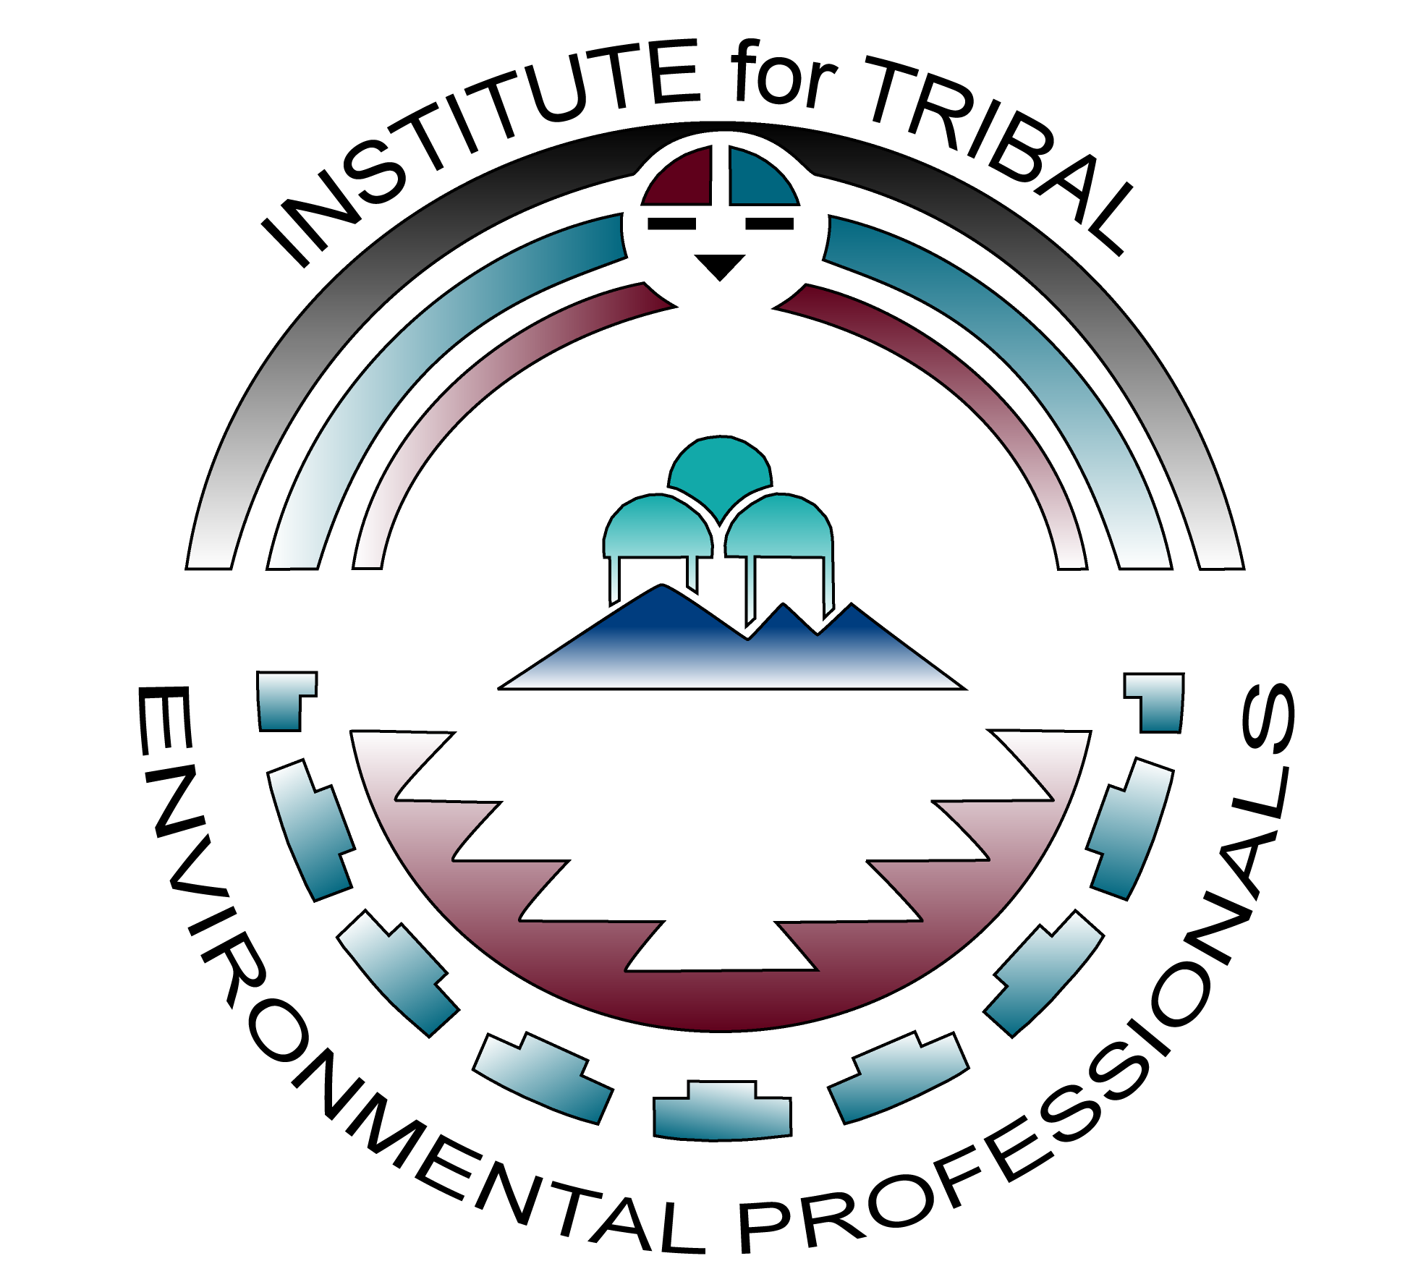

Institute for Tribal Environmental Professionals

Development and Implementation of Tribal Solid Waste

Codes and Ordinances Training

VIRTUAL COMPONENT: February 13-16 and March 8, 2023 AND
IN-PERSON WORKSHOP: April 25-27, 2023 in Minneapolis, Minnesota
Application Deadline: January 13, 2023

The Institute for Tribal Environmental Professionals, the Indian Health Service (IHS), and the United States Environmental Protection Agency (USEPA) are pleased to offer “Development and Implementation of Tribal Solid Waste Codes and Ordinance” training course to employees of federally-recognized tribes that have completed integrated solid waste management plans but lack operable solid waste codes/ordinances. This training includes an online course, online assignments, and a follow-up in-person workshop to focus on the writing and implementation of effective tribal solid waste codes. Each tribe that completes these components will receive legal and technical staff support via phone, email, and/or web-based meeting communication including include one-on-one assistance in developing and implementing their codes and ordinances for up to one year following the completion date of the in-person workshop. Complete attendance is required to receive legal and technical staff support and a certificate.

COURSE HIGHLIGHTS
Importance of Developing Community-Specific Codes & Navigating the Jurisdictional Labyrinth
Drafting Codes – Conducting Research and Deciphering Code Language & Identifying Solid Waste Issues
Outreach Methods & Strategies for Cultivating Public, Legal, and Governmental Support
Enforcement Issues, Enforcement Options, Enforcement Alternatives
Conducting/Managing Legal Review/Administrative Processes

ELIGIBILITY
This tuition-free course is specifically designed for tribes who intend to create solid waste codes, or to improve existing solid waste codes, and are in a position to enforce the completed codes. Course participants must be employees of federally-recognized tribes that currently have completed integrated solid waste management plans but lack operable solid waste codes/ordinances.

APPLICATION PROCESS
Participants applying for the “Development and Implementation of Tribal Solid Waste Codes and Ordinance” training are required to complete ITEP’s online application available at: https://bit.ly/Codes2023Application.

This training will be limited to twenty-five participants and is competitive. Completing an application does not guarantee acceptance. A notice of confirmation and fact sheet with additional course details will be sent to those who are selected to attend the course.

PARTICIPANT REQUIREMENTS
Attendees accepted to the “Development and Implementation of Tribal Solid Waste Codes and Ordinance” training are required to:
- Complete a pre-course assignment, pre-test, and self-assessment (requires approximately 2-4 hours) by February 6, 2023.
- Attend the online portion of the course Feb 13-16, 2023, and March 8, 2023.
- Complete online course work (requires an additional 20-30 hour commitment from February 17, 2023 through March 31, 2023), including assignments, discussions forums with other course participants, and drafting a SW code prior to the follow-up workshop.
- Attend the 2½-day follow-up Solid Waste Codes and Ordinances Workshop on April 25-27, 2023 in Minneapolis, Minnesota to help complete the development of a successful code.
- Commit to the development/revision and implementation of a solid waste management code or ordinance within 12 to 18 months of completing this training.

TRAINING DATES, TIMES, AND LOCATIONS
The 20 hours of virtual training via Zoom (with cameras turned on) is scheduled for the following dates and times:
- February 13, 14, 15, 16, 2023: (9am-2pm PST; 10am-3pm MST; 11am-4pm CST; 12pm-5pm EST)
- March 8, 2023: (10am-12pm PST; 11am-1pm MST; 12pm-2pm CST; 1pm-3pm EST)
The follow-up in-person workshop will be held in Minneapolis, Minnesota:
- April 25, 26, 27, 2023: This training will be delivered 8:00am-5:00pm on Tuesday and Wednesday, April 25-26 and 8:00am –12:00pm on Thursday, April 27, 2023.

TRAVEL AND LODGING
Participants selected to attend the course will be responsible for their own travel, lodging, and per diem expenses for the in-person workshop. Participants should arrange their travel to arrive before 7:30am on Tuesday, April 25 and depart after 2:00 pm on Thursday, April 27.

CANCELLATIONS
Please notify ITEP as soon as possible if you need to cancel. No-shows impact opportunities for other tribes to attend and will jeopardize your eligibility for future trainings.

Call or email Julie Jurkowski at Julie.Jurkowski@nau.edu or 928-523-9404 with questions.

