Community EventS

Tel: 928-523-8864/1496
WINS :
Wildlife In Native Schools

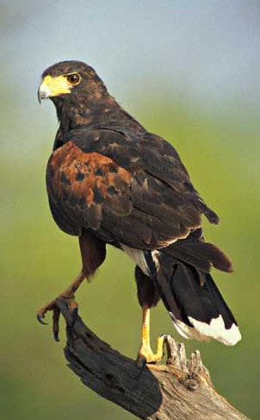

As part of the WINS project, we will be
conducting Community based education events coinciding with spring and fall raptor
migrations through Arizona. These events will bring agencies such as AZGF, NAU, NNFW, NPS and High Country Raptors of Flagstaff
together to provide education for families.
During these event participants will have the opportunity to meet rehabilitated raptors, view wild migrating raptors, and learn about the basics of ecology and habitat protection. We hope to make these and annual event with the help of local partnerships.

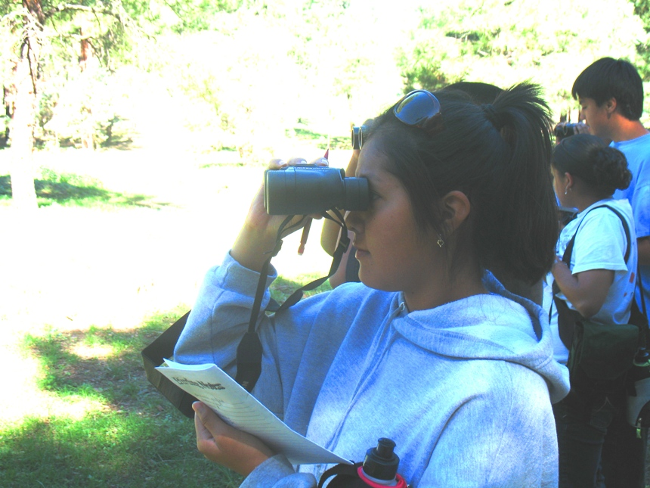
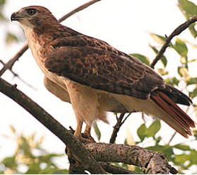

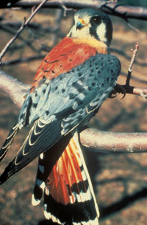

Environmental Education Outreach Program
Contact: Matthew Zierenberg
Matthew.Zierenberg@NAU.EDU
PO Box 5768
Flagstaff, AZ 86011
Peterson Hall, Building 22
Rooms 202, 204, 206, 208
Phone: 928-523-8864/1496
Fax: 928-523-1280
www4.nau.edu/eeop/
Northern Arizona University
Harris Hawks
American Kestrel

Students Identify Birds on the
San Carlos Reservation

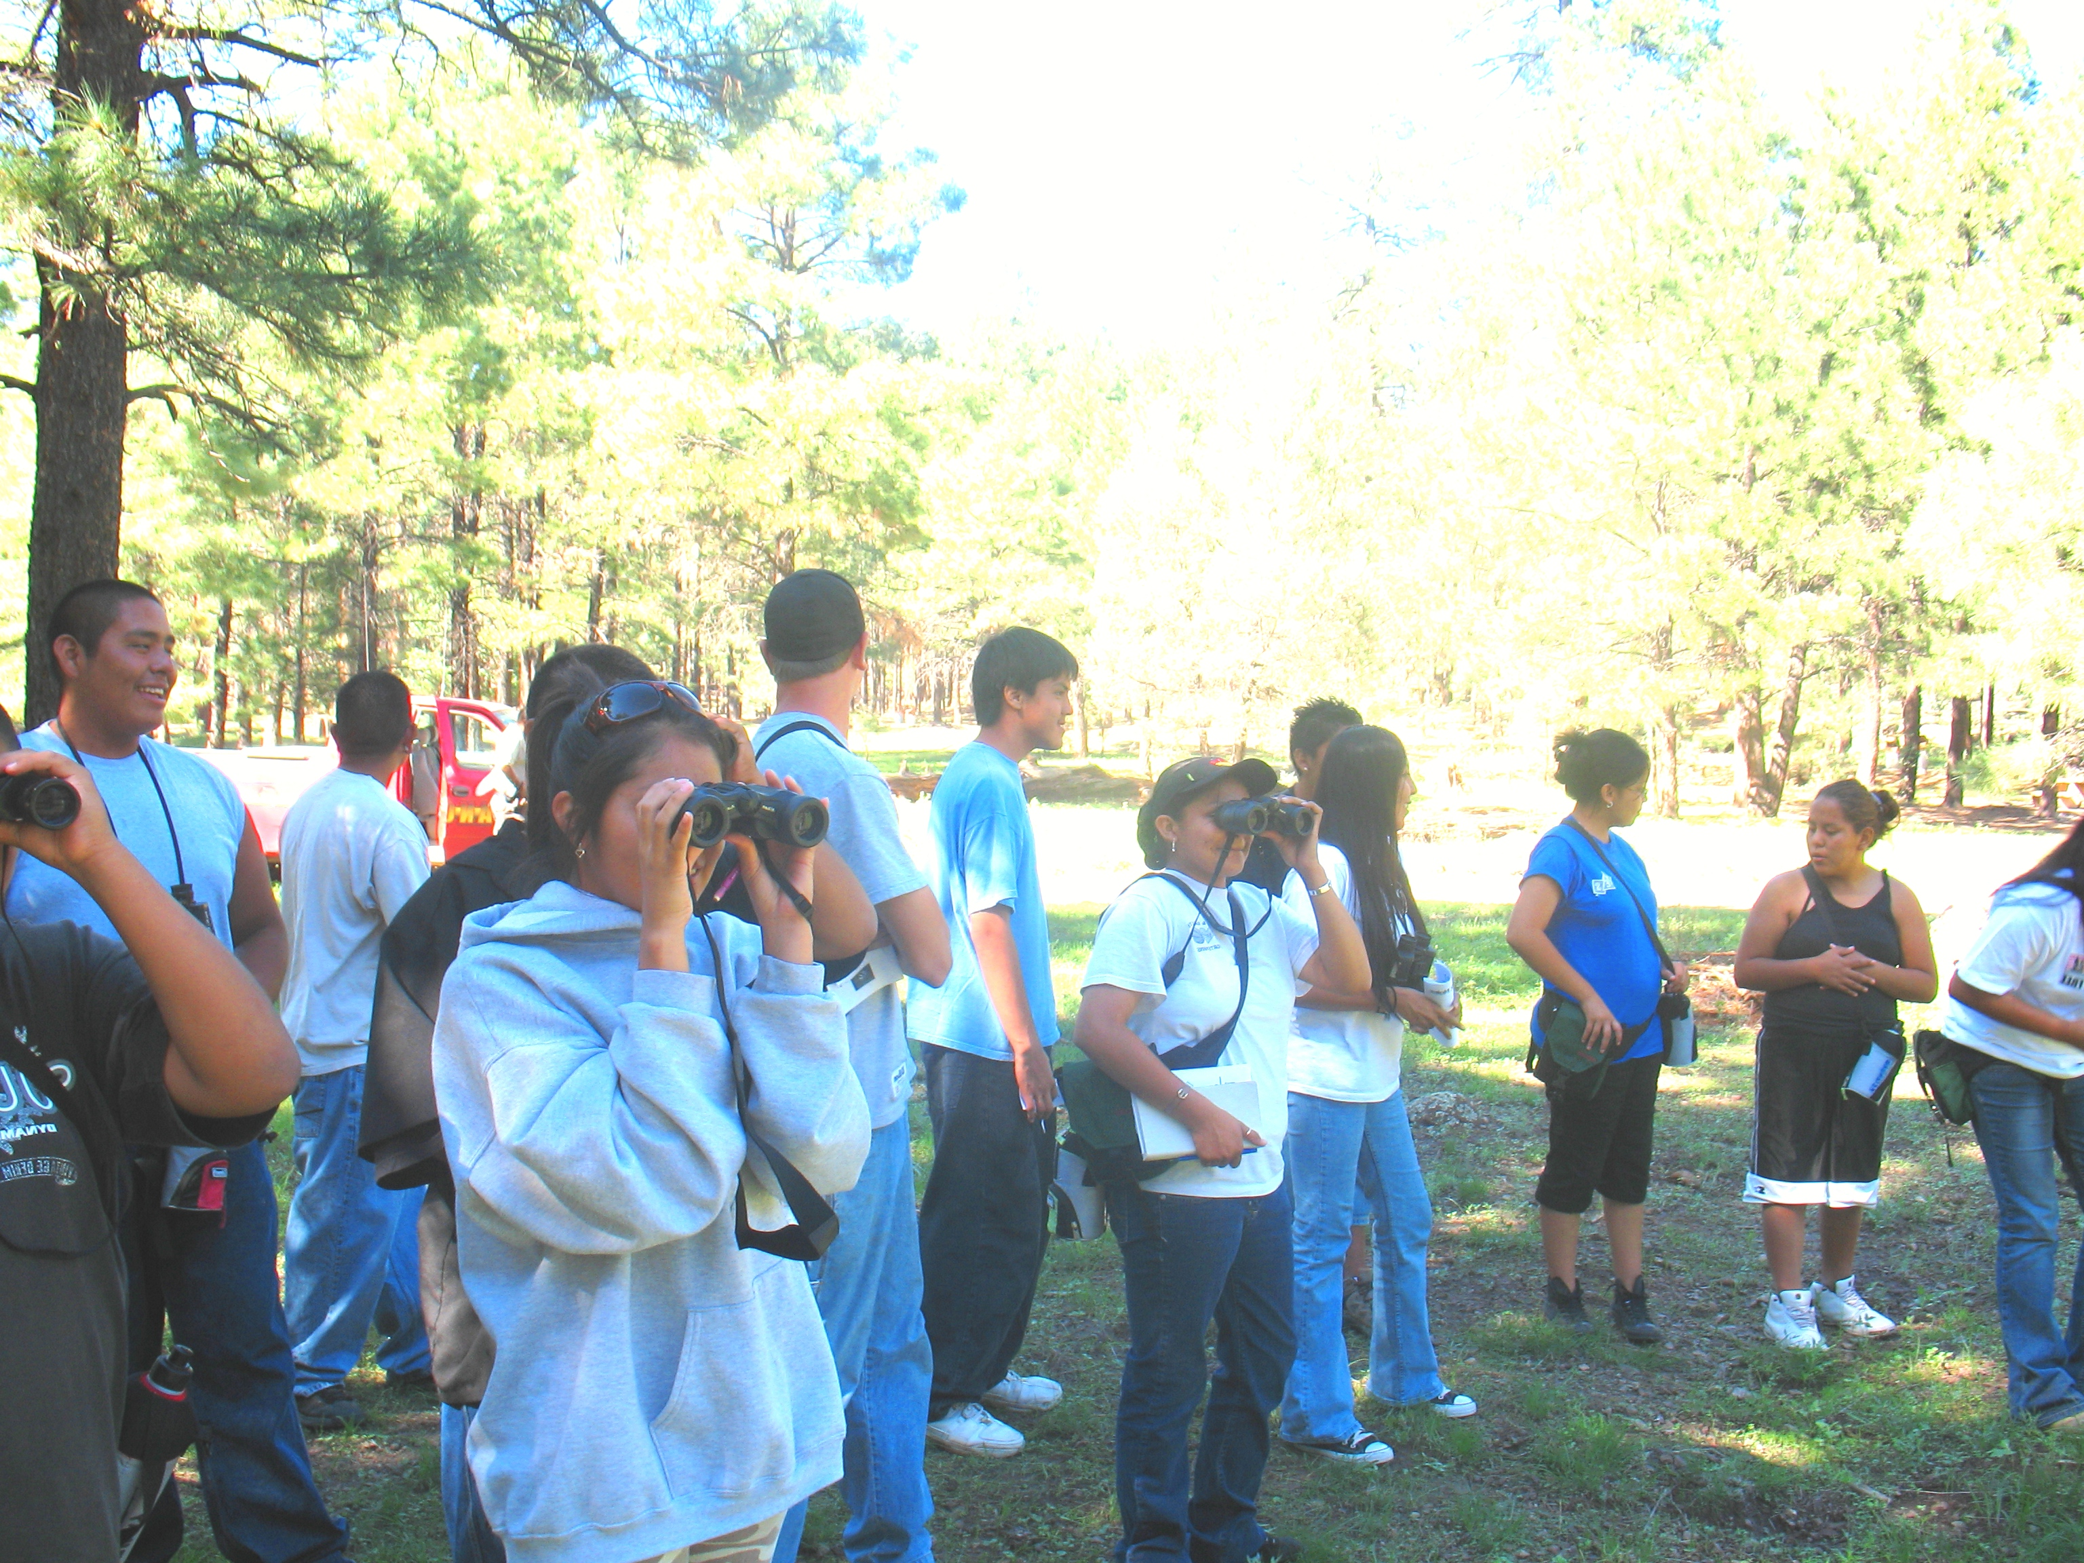
Helping students and Teachers learn from and observe the world around them.

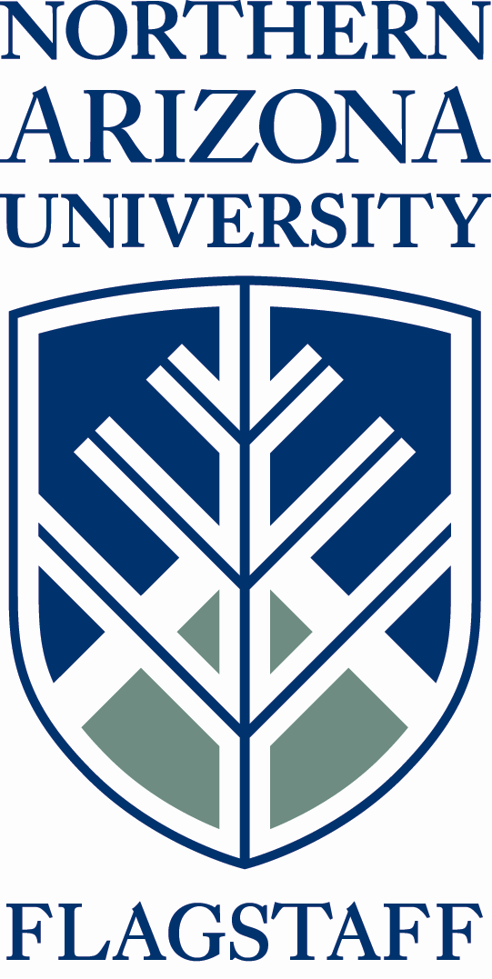
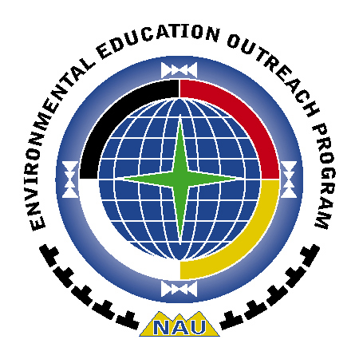
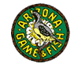

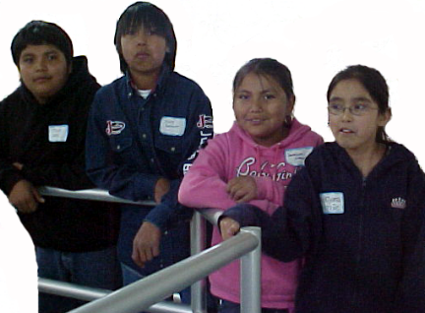

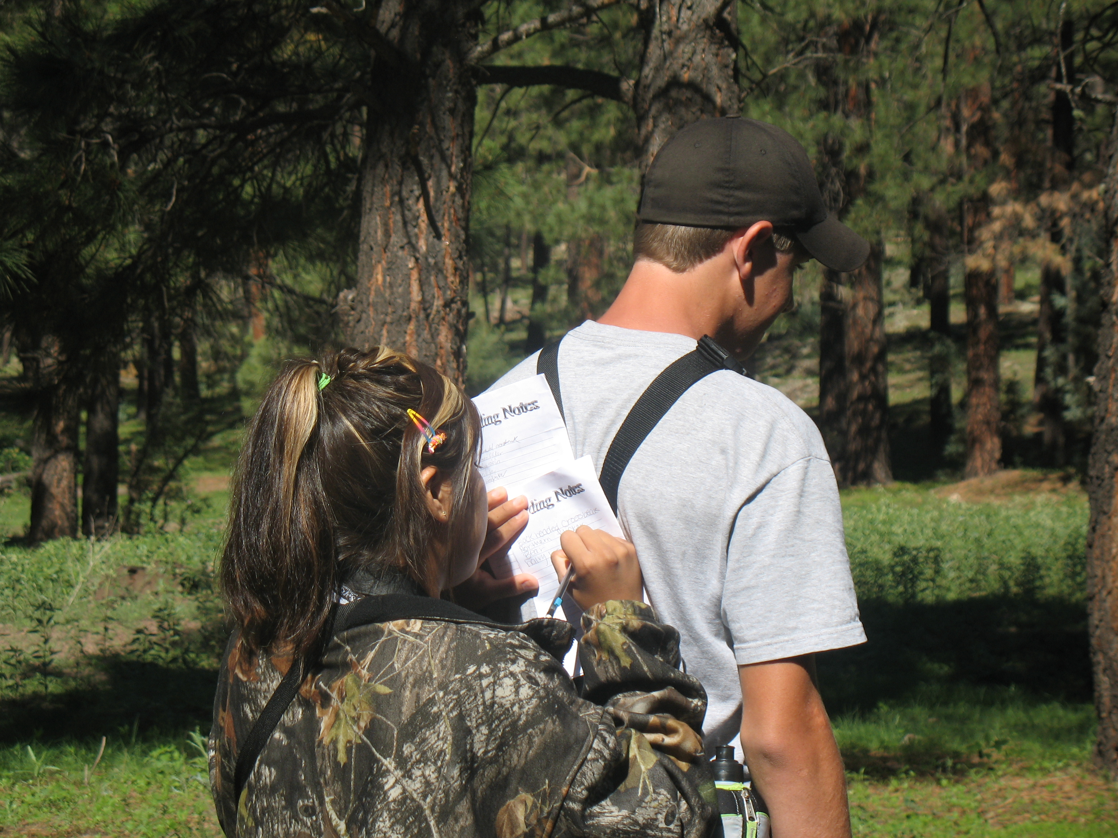
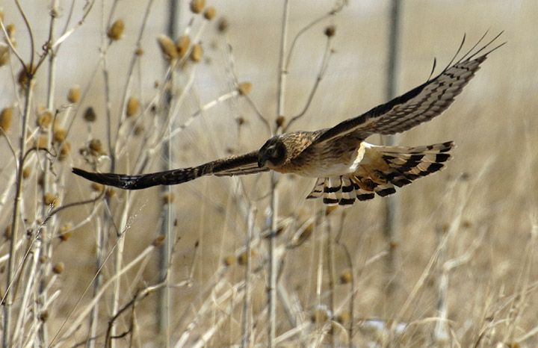
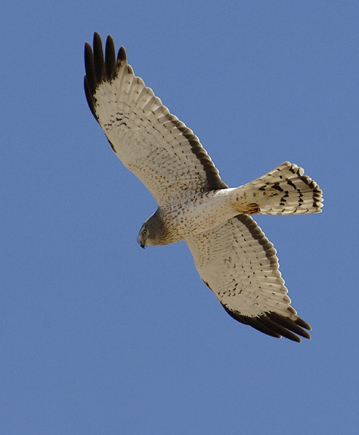

The WINS program will consist of many different activities such as a teacher workshop, classroom presentations, observational field trips and community events.
Topic areas for these activities will focus on predator-prey relationships, food chain, biodiversity, wildlife career opportunities, and the effects of good or poor air, water, and soil quality on an ecosystem.
During these activities, scientists and experts will be brought in as guest speakers to help teach these principles through local, real life examples. Guest speakers will be invited from various groups such as NAU faculty, tribal elders, U.S. Fish and Wildlife, and Arizona Game and Fish department officials. They will serve as role models for students that may be interested in pursuing a career in wildlife management.
Wins Program
Activities
One of the major goals of the WINS Program is to see students get excited about learning. This excitement can develop into a love of learning that will serve them throughout their lives. We hope that this program can be a catalyst leading students to pursue a higher education and take an active role in protecting and conserving our natural heritage.
Curriculum
Content for the program is taken from various curriculum projects Project Wild, GLOBE, Project Learning Tree, Focus Arizona Wild, and other NSF funded Curricula.
Proposed Activities
Ecology Activities
Scientific Measuring
Observing Wildlife and Habitat
Service Learning
Classroom education
Group Research
Gathering Data
FUNDING
This program is made possible by a grant from the Arizona Heritage Foundation in cooperation with the Arizona Game and Fish Department. Additional sponsors of this program include:
NAU’s Institute for Tribal Environmental Professionals
National Parks Service
High Country Raptors
Navajo Nation Fish and Wildlife Department
Office of Dine Science, Math, and Technology.
Bridging the gap to
higher
education!

Environmental Education Outreach Program
Contact: Matthew Zierenberg
Matthew.Zierenberg@NAU.EDU
PO Box 5768
Flagstaff, AZ 86011
Peterson Hall, Building 22
Rooms 202, 204, 206, 208
Phone: 928-523-8864/1496
Fax: 928-523-1280
www4.nau.edu/eeop/
Northern Arizona University
Harriers in Flight

